**Green Society Public School**

**D-07**

**Ratnanagar-7, Sauraha, Chitwan**

**Second Terminal Examination-2082**

**Class: LKG Time: - 2 hrs. F.M.: 50**

**Sub: Project Work**

|  |
| --- |
| **Name: Roll No.: Sec.:** |
| **­­­­­­­­­­­­ ________________ ______________ OBT.MARKS:**  **INVIGILATOR EXAMINER** |

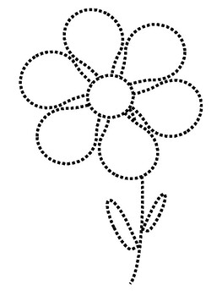**1. Join the dots and colour it. (10)**



**2. Draw a butterfly and colour it. (10)**

Butterfly

**3. Complete the given shapes and colour it. (10)**

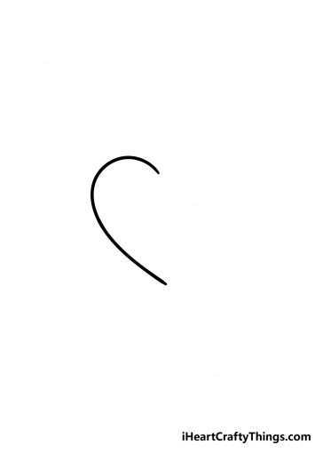

**4. Colour the same pictures. (10)**

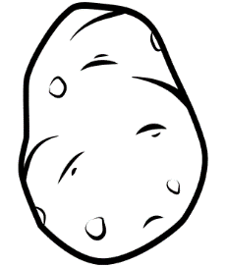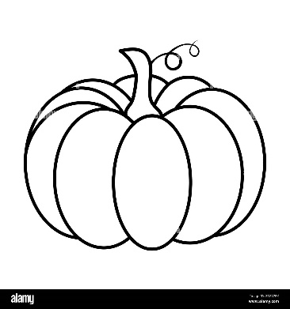

**=**

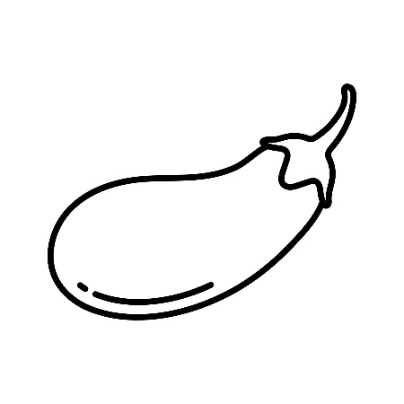

**=**

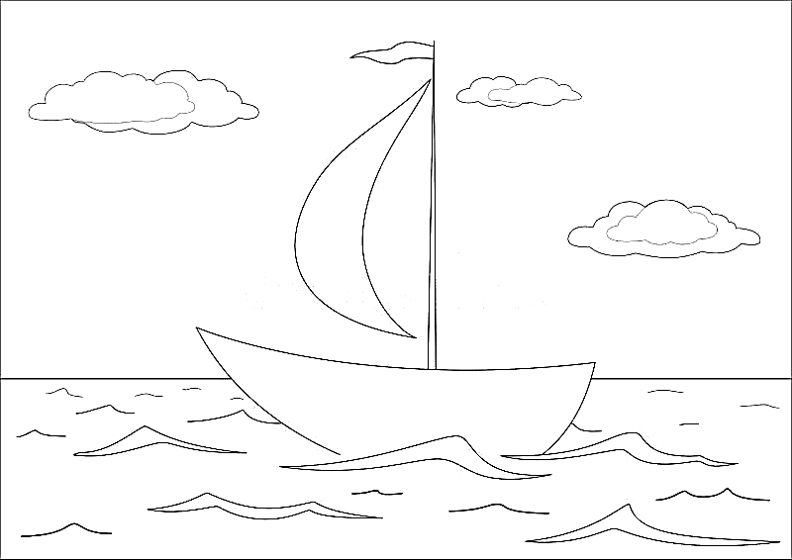**5. Colour it. (10)**

**The End**